Working Scientifically – Progression Map
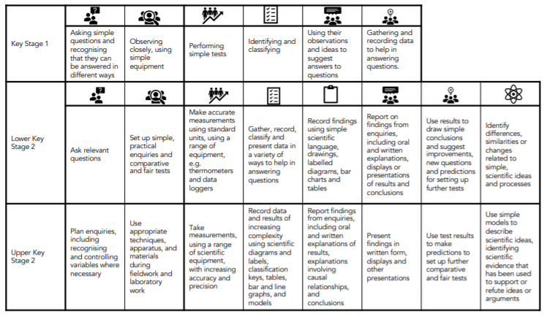
Science Long Term Map

